Activity Overview  In this activity, students are introduced to the important topic of simple harmonic motion in terms of the motion on a swing. Using multiple representations to support understanding, students derive the defining formulas—first, beginning with the trigonometric relationship between time and displacement, and differentiation to the form for acceleration, and then by integration from acceleration back to displacement. This activity provides an introduction to differential equations.  Topic: Applications of Integration  - Solve the differential equation for simple harmonic motion and graph its solution to explore its extrema.  Teacher Preparation and Notes  - This investigation offers opportunities for review and consolidation of key concepts related to differentiation and integration of trigonometric functions. It provides a firm link between the theory and applications of the Calculus. Care should be taken to provide ample time for all students to engage actively with the requirements of the task, allowing some who may have missed aspects of earlier work the opportunity to build new and deeper understanding.  - This activity can serve to consolidate earlier work on differentiation and integration. It offers a suitable introduction to differential equations.  - Begin by reviewing the method of differentiation of trigonometric functions and methods of integration of the standard function forms.  - To download the student worksheet, go to education.ti.com/exchange and enter “10037” in the keyword search box.  Suggested Related Activities  To download any activity listed, go to education.ti.com/exchange and enter the number in the keyword search box.  - Differential Equations (TI-Nspire CAS technology) — 8998  - Damped and Driven Harmonic Motion (TI-Nspire CAS technology) — 9523 | 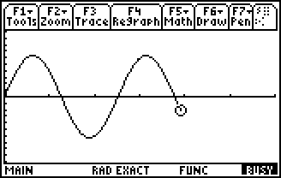  This activity includes screen captures taken from the TI-89 Titanium.  Compatible Devices:  - TI-89 Titanium  Associated Materials:  - SimpleHarmonicMotion _Student.pdf  - SimpleHarmonicMotion _Student.doc  Click HERE for Graphing Calculator Tutorials.

Problem 1 – Motion of a Swing
Begin with a discussion and review of both differentiation and integration of standard forms and of trigonometric functions in particular. Ensure that students are comfortable with these, and then challenge them to apply what they know about these processes to real-world situations, with a particular focus upon rates of change.
Students are to graph the given displacement equation for the swing and the subsequent derivative graphs.  If students are not using CAS technology, they can graph the equations for y2 and y3 by finding the derivative by hand.  After each graph, students should answer the questions on the worksheet. | 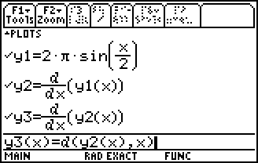  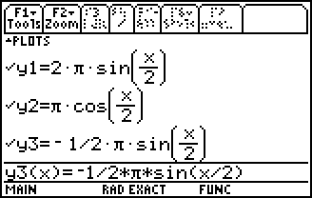
Motion on a swing should be something to which all students can relate. It offers a suitable context for a closer examination of rates of change of displacement leading to velocity, and rate of change of velocity leading to acceleration. | 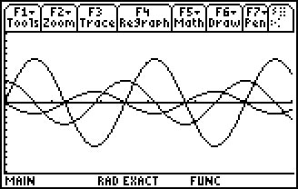
Particular care should be taken to build understanding of the concept of acceleration—while students will relate readily to displacement and velocity, acceleration is best introduced in terms of an applied force (being careful to distinguish between them!). Once established, this forms the basis for deriving the forms for simple harmonic motion, beginning with the standard relationship between time and displacement, leading to velocity and finally to acceleration. Substituting back leads readily to the defining equation in terms of acceleration and displacement.

Problem 2 – Extension
The second part of this activity is a series of extensions, beginning with the challenge for students to describe other examples of simple harmonic motion. Then, they should be introduced to the variety of forms of acceleration, and attempt to justify these from their knowledge of rates of change.
What follows supports students in deriving the simple harmonic forms by integrating from the acceleration equation. This involves some substitution of critical values drawn from the physical example of the child on the swing and, finally, integration of inverse trigonometric function forms. When deriving this form, students should be encouraged to discuss the use of the sine or the cosine form—each appropriate depending upon the physical conditions. This should lead to consideration of the phase shift as related to the starting point of the motion.
The information to show the standard format formula for simple harmonic motion appears below. Please go over this work. The rest of the answers are found in the Student Solutions section on the next page.
This gives .
When
and recall
Integrate both sides with respect to x:
When t = 0, x = 0, then C = 0 and therefore x = A sin(nt).

Student Solutions
1. Point A is at the minimum or maximum and point P is at the x-intercept of the curve.
2. You move fastest as you pass through the center of the swing’s path, and you stop (briefly) at each end of the path.
3. Point A is at the x-intercepts and point P is at the minimums or maximums of the curve.
4. Acceleration/force will be greatest when you are furthest from the ground—at each end of the path. It will be least when you are at your lowest point, in the middle.
5. Point A is at the minimums or maximums and point P is at the x-intercepts of the curve.
6. If the origin of the motion is taken to be the center of the swing’s path (where the acceleration/force is least) then the further you move away from that position, the greater the acceleration/force acting upon you trying to return you to that position.
7. If where and T is the number of seconds to complete one cycle, then
8.
9. Given and , , so .
10. The force/acceleration acting upon a child on a swing acts in a negative direction to the motion, proportional to the square of the period and the displacement from the origin—in other words, the further you are from the “rest position” the more force there is from gravity to return you there!
11. At the origin, displacement = acceleration = 0, while velocity has a maximum value. At the end points, velocity = 0 while displacement and acceleration attain their maximum values.
Extension Solutions
EX 1 Most musical instruments (e.g., a guitar string when plucked, reed in a wind instrument—hence the name simple harmonic motion); The tides and even a cork or object moving up and down with the tides.
EX 2
EX 3
EX 4 It depends on where the motion begins. If x = 0 when t = 0, then sine is the most appropriate. If the motion begins from one of the endpoints (someone pulling the swing back before releasing), then cosine would be the better choice.

